1. Create a React Application named “ticketbookingapp” where the guest user can browse the page where the flight details are displayed whereas the logged in user only can book tickets.

The Login and Logout buttons should accordingly display different pages. Once the user is logged in the User page should be displayed. When the user clicks on Logout, the Guest page should be displayed.

CODE:

GuestPage.js

import React from 'react';

const GuestPage = () => (

  <div>

    <h2>Welcome, Guest!</h2>

    <p>Here are the available flight details:</p>

    <ul>

      <li>Flight A: Delhi → Mumbai</li>

      <li>Flight B: Kolkata → Bangalore</li>

    </ul>

  </div>

);

export default GuestPage;

UserPage.js

import React from 'react';

const UserPage = () => (

  <div>

    <h2>Welcome, User!</h2>

    <p>You can now book your flights:</p>

    <button>Book Flight</button>

  </div>

);

export default UserPage;

LoginButton.js

import React from 'react';

const LoginButton = ({ onLogin }) => (

  <button onClick={onLogin}>Login</button>

);

export default LoginButton;

LogoutButton.js

import React from 'react';

const LogoutButton = ({ onLogout }) => (

  <button onClick={onLogout}>Logout</button>

);

export default LogoutButton;

App.js

import React, { useState } from 'react';

import GuestPage from './components/GuestPage';

import UserPage from './components/UserPage';

import LoginButton from './components/LoginButton';

import LogoutButton from './components/LogoutButton';

function App() {

  const [isLoggedIn, setIsLoggedIn] = useState(false);

  const handleLogin = () => setIsLoggedIn(true);

  const handleLogout = () => setIsLoggedIn(false);

  let pageContent;

  if (isLoggedIn) {

    pageContent = <UserPage />;

  } else {

    pageContent = <GuestPage />;

  }

  return (

    <div className="App">

      <h1>Ticket Booking App</h1>

      {isLoggedIn ? (

        <LogoutButton onLogout={handleLogout} />

      ) : (

        <LoginButton onLogin={handleLogin} />

      )}

      {pageContent}

    </div>

  );

}

export default App;

OUTPUT:

1. Guest view

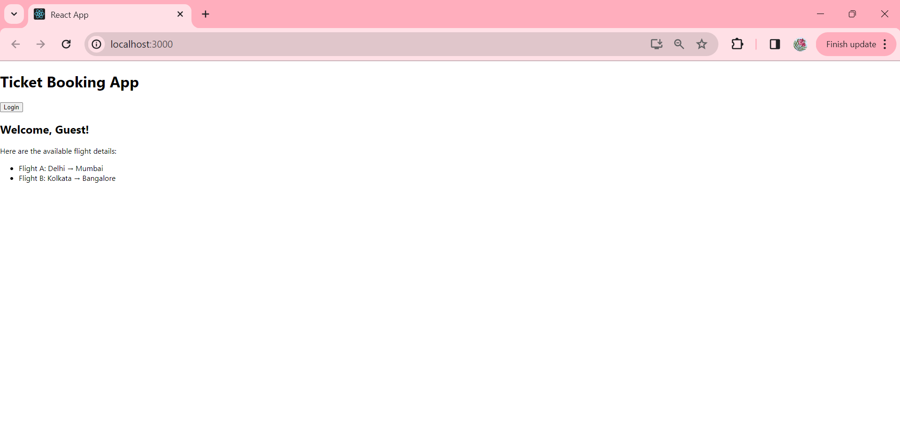

1. User view

